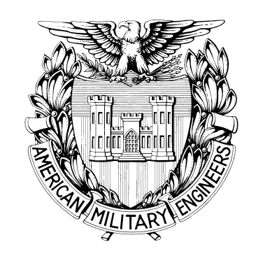

Society of American Military Engineers

Robins AFB Post
2012 Engineering and Construction Camps

The Engineering & Construction Camps committee develops strong partnerships with Posts in order to encourage participation in the annual SAME Engineering & Construction Camps. Camp participants discover the endless possibilities and benefits of service academy enrollment, with the goal of strengthening the nation's infrastructure by pursuing careers in, and related to, military engineering/public service. By increasing Sustaining Member participation, the committee and the Posts will continue to enhance the educational value of the camps and bring more participants.
Each year SAME sponsors four Engineering & Construction Camps for high school students to provide them with first-hand experience in engineering and construction. The U.S. Air Force Academy (Colorado Springs), U.S. Navy Seabees (Port Hueneme, CA), U.S Marine Corps (Camp LeJune, NC) and U.S. Army Camp (Vicksburg) are camp co-sponsors.
The Robins Air Force Base SAME Post will sponsor one high school student to either the Air Force, U.S. Navy, or U.S. Marine Corps 2012 camps. The Robins AFB Post will pay registration and travel expenses to attend one of these camps.

ELIGIBILITY CRITERIA:
- Student must be a U.S. Citizen.
- The student must have completed at least their freshman year of high school.
- The student must still be enrolled in school at the time of the camp.
- Be on a high school track that will provide a basis for attending an accredited engineering college or university (i.e., taking appropriate math and science courses).
- Have an expressed intent to pursue a degree in architecture, engineering or a related field.
- Have demonstrated leadership characteristics through participation in extra-curricular activities, sports, and/or community activities.
- Students must have a minimum GPA of 3.3 on a 4.0 GPA scale.
- Be physically fit and healthy (not have any physical limitations including, but not limited to the following: a requirement to take mandatory medication that requires special handling; sprained joints; or, neck, shoulder, or back injuries).
- Be of high moral character.
- Students who have attended an SAME Engineering and Construction Camp prior to this year will not be eligible to attend the same camp. Students are eligible to attend a specific camp once only.
- Students must be sponsored by a local SAME Post. Please see the Camp Application Process for details.
ADDITIONAL FOR THE USAFA CAMP:
- If the student is completing their junior year of high school, they must provide some proof of an expressed interest in applying to a Service Academy or ROTC Program (this does not include JROTC).
APPLICATION CHECK LIST

- Engineering and Construction Camp Application
- Medical Release Form
- Emergency Notification Form
- Competitive Selection Resume

SELECTION:
- A board of SAME officers will select one student to attend one of the engineering and construction camps.
- Selection will be based on academic achievement, character, personal merit, and commitment towards the field of engineering. Merit is demonstrated through leadership in school, civic and extracurricular activities, academic achievement, and motivation to serve and succeed. Resume should reflect these qualities in order to be selected.
- Selection will be made with no regard to race, color, creed, sex, or national origin.

SCHOLARSHIP AWARD:
One student Registration FEE and travel expenses to and from a single Engineering & Construction Camp

Send the completed application and supporting materials to:

778th Civil Engineer Squadron
505 Page Road
Robins AFB, GA 31098
Attn: Mr. Brett Williams
Or, fax to: 478-926-7598, Attn: Brett Williams, no later than March 30, 2012

For questions contact Mr. Brett Williams
Phone: (478) 293-0139
brett.williams@robins.af.mil

Submission deadline is March 30, 2012.

